_______________________ Pre / Post FMT Check up

How has your general disposition been lately?
Really happy Happy Just ok Bummed Totally Depressed.

Please rate your pain according to the chart, since your last survey.
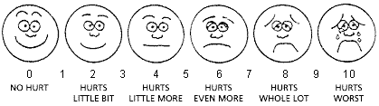
Abdominal Pain
0 1 2 3 4 5 6 7 8 9 10

Average Energy Level
Exhausted Tired Just enough Good energy Jet speed!

Activity Level
No limitation to activity Occasional limitation Severely restricted activity

Bleeding
No bleeding | Moderate bleeding sometimes
Light bleeding sometimes | Moderate bleeding always
Light bleeding always | Heavy bleeding sometimes
 | Heavy bleeding always

Stool
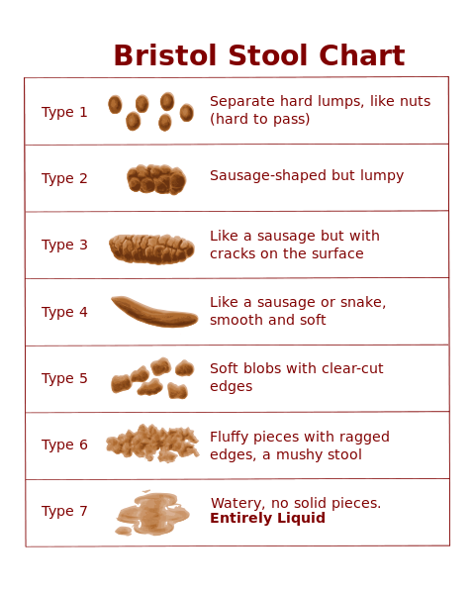
What is the consistency of your average stool?
1 2 3 4 5 6 7

What’s the average number of times you go per day?

